**Week 3 – Shallow Neural Network**

**Neural Network**

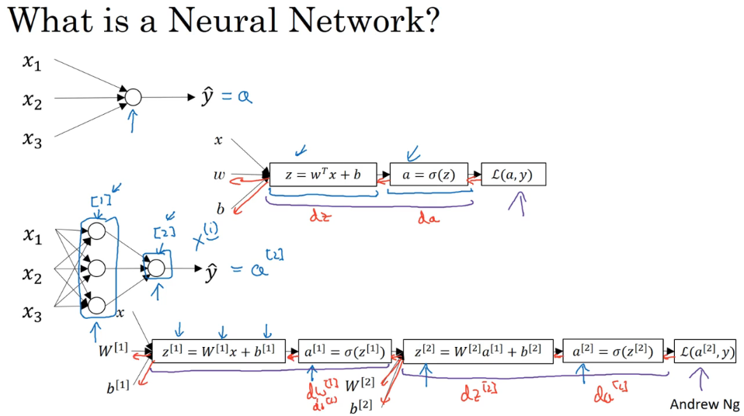

Basically take a logistic regression but you repeat it twice.

**Neural Network Representation**

We will start looking at what is called a hidden layer. You only ever see what the inputs are and what the outputs are but you never see a hidden (not seen) in the **training set. a[0] = x (refers to the activations). a[2] is a real number.**

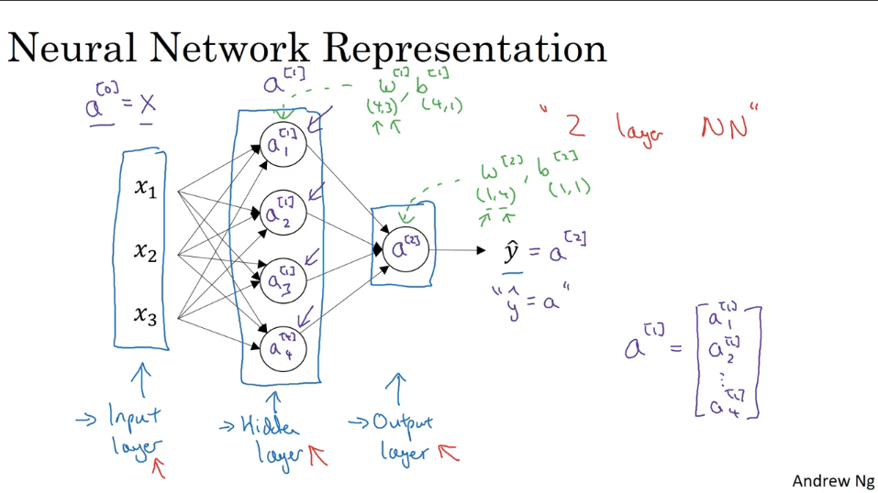

**Computing a Neural Networks Output**

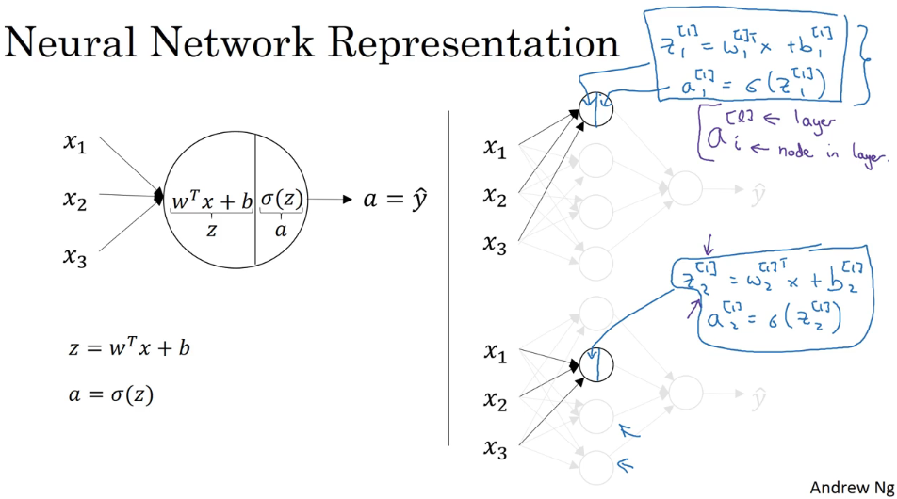

To compute these, we are going to vectorizer them.

Rule of thumb, when you have different nodes in a layer, you stack them vertically. That’s why, you have Z[1]1…Z[1]4.

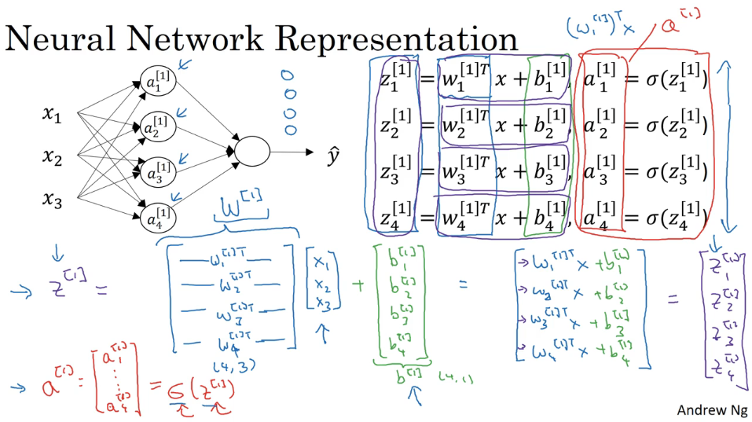

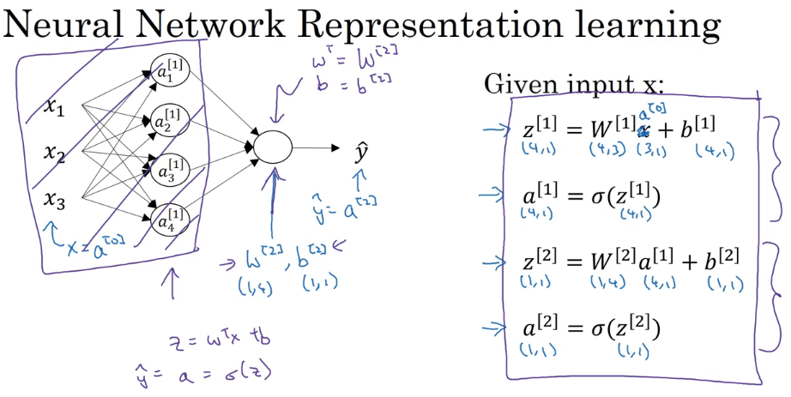

All you need to compute a shallow neural network is those four lines of code.

**Vectorizing Across Multiple Examples**